**Project Progress Report __________________________________________________________________**

**Semester: 8th**

**Project Title: A Web GIS application for integration of socio-economic, biophysical and atmospheric variables: A case study of Punjab province**

# Supervisors: DR.Hammad Gillani and Mam Aneeqa Abrar

# SUBMITTED BY: Syed Mustafa Haider and Akram Ali Shah,

**Reg. Number: 160601009,160601023**

Contents

**1 Introduction** 2

**2 Literature review** 2

2.1 Web-GIS 2

2.2 Bootstrap framework 2

2.3 Utilization of Web-GIS for Spatial analysis 2

2.4 Table 3

**3 Methodology** 4

3.1 Data Collection 4

3.1.1 The Study area: 4

3.1.2 Data Parameters and collection: 6

3.1.3 Creation of Thematic Map in ArcMap: 7

3.2 Geospatial portal development 9

3.2.1 Creation of a Prototype Webpage/Web-GIS browser application: 9

3.2.2 Incorporation of Data into the webpage in order to create thematic map: 10

3.2.3 Plugins used in the Geospatial web-portal: 11

**References** 11

# **1 Introduction**

Maps are wonderful not only do they tell you where to go but they also convey a story. In early times the maps were on papers but as time passed new technologies were discovered such as the computer and the internet, now maps were in the screens of the computers rather than pages. GIS (geographic information system) was a system developed to store, manipulate, analyze and manage spatial data. At one time Desktop Gis was the means for handling and representing spatial data but the trends have now shifted to Web based Gis which has several advantages such as accessibility, representation of spatial and non-spatial data in real time, sharing of data and it is easy to operate.

This project named “A Web GIS application for integration of socio-economic, biophysical and atmospheric variables: A case study of Punjab province” aims to visualize Population density, Land Surface Temperature, Air quality Index and Precipitation data over the range of 2010-2019 of Punjab in the form of Thematic Maps on a geospatial web portal. A thematic map as the name implies is a map which represents a theme associated with a specific geographic area. These Maps would visually inform the user the change in the above mentioned parameters over the years. The project would include graphs for graphical representation of the parameters.

# **2 Literature review**

## 2.1 Web-GIS

Web GIS is a tool or a product of digital mapping that is based on internet network as its medium of communication. Functions of Web GIS as the communication media are to show, deploy, integrate, provide spatial and non-spatial information in various forms (such as digital maps, texts, diagrams), and run the main functions, namely analysis and queries which are still associated with GIS technology through internet network[1].

## 2.2 Bootstrap framework

It is one of the most well-known frameworks used for web development, it is used for website front end development. Generally it is used to make responsive projects in HTML, CSS and java script. It saves time in styling webpages.

## 2.3 Utilization of Web-GIS for Spatial analysis

Web-GIS has been used for spatial analysis in a lot of cases as it provides efficient, easy and interactive means for displaying spatial information. Generally spatial information is displayed on a Geospatial webpage or application through the utilization of JavaScript libraries such as Leaflet and OpenLayers or through mapping servers like GeoServer. Geographic information can be displayed on the internet in a variety of forms. One of the basic forms of representing Geographic information is through thematic maps which can be used to create solutions supporting local leadership and decisions maker for making decisions regarding planning related to an issue [2] .Earthquake information can be displayed in a dynamic map browser type of web mapping applications [3]. Information Such as environmental pollution can be displayed and monitored through maps on a geospatial webpage [1]. Geospatial web portals can be used in the assessment of natural disasters like tsunamis [4].

## 2.4 Table

The following table represents the important features (Web-GIS) in the various literature relating development of geospatial webpages and applications for spatial analysis. These features would be taken in consideration during the webpage development process

|  |  |  |  |  |  |  |
| --- | --- | --- | --- | --- | --- | --- |
| **FEATURES** | L. Liu, D. Li, and Z. Shao, “Design and implementation of a geospatial portal,” in *Geoinformatics 2008 and Joint Conference on GIS and Built Environment: Geo-Simulation and Virtual GIS Environments*, 2008, vol. 7143, no. August 2015, p. 71432E | H.Lin *et al.*, “A geospatial web portal for sharing and analyzing greenhouse gas data derived from satellite remote sensing images,” *Front. Earth Sci.*, vol. 7, no. 3, pp. 295–309, 2013 | R. Olyazadeh, K. Sudmeier-rieux, M. Jaboyedoff, M. Derron, and S. Devkota, “An offline – online Web-GIS Android application for fast data acquisition of landslide hazard and risk,” *Nat. Hazards Earth Syst. Sci.*, vol. 17, no. 4, pp. 549–561, 2017 | A. N. Anna and V. N. Fikriyah, “Environmental pollution monitoring using a Web-based GIS in Surakarta,” *IOP Conf. Ser. Earth Environ. Sci. Pap.*, vol. 314, 2019.. | D. S. Rathore, D. Chalisgaonkar, R. P. Pandey, T. Ahmad, and Y. Singh, “A Web GIS Application for Dams and Drought in India,” *J. Indian Soc. Remote Sens.*, vol. 38, no. 4, pp. 670–673, 2010, doi: 10.1007/s12524-010-0054-2. | K. Observatory, C. Istanbul, T. Land, F. Command, and C. E. Faculty, “Developing a Web-Based Gis Application for Earthquake Information,” |
| **Thematic maps** | ⮿ | ☑ | ⮿ | ⮿ | ☑ | ☑ |
| **Interactive maps** | ☑ | ☑ | ☑ | ☑ | ☑ | ☑ |
| **Real-time Spatial data analysis** | ⮿ | ☑ | ☑ | ⮿ | ⮿ | ☑ |
| **Data downloading** | ☑ | ☑ | ☑ | ☑ | ⮿ | ☑ |
| **Map navigation menu(map tools)** | ☑ | ☑ | ☑ | ☑ | ☑ | ☑ |
| **Graphs** | ⮿ | ☑ | ☑ | ⮿ | ⮿ | ⮿ |
| **User change accommodation** | ⮿ | ⮿ | ⮿ | ☑ |  | ☑ |

# **3 Methodology**

## 3.1 Data Collection

### 3.1.1 The Study area:

The word Punjab literally means “five waters” which is referring to Jhelum, Chenab, Ravi, Beas, and Sutlej rivers, which are tributaries of the Indus River. Punjab is situated in the 31°N 72°E (latitude and longitude) coordinates. Punjab is one of the most important province of Pakistan. The total area covered by Punjab is 205,344 km2 ,its capital is the city of Lahore which is located in the east central region near the border with India. Punjab Is a land rich for agriculture purposes, however it has its share of issues. One of the said issues is Population, Punjab is already the most populated province of Pakistan with an estimated population of 110,012,442 approximately as of 2017 census. The increasing Population of Punjab is a serious problem which leads to economic consequences. Greater the population greater is the demand off goods such as food, etc. Hence for a country like Pakistan with limited industries, this means greater inflation (which results in various other problems). Population increase also causes an increase in the Pollution of the environment, the pollution to be noted is the pollution of air which greatly effects the life of the civilians. According to the 2015 findings of the medical journal Lancet, a whopping 22 percent of annual deaths in Pakistan are caused by pollution, and the majority of those are due to air pollution [5]. The main Gasses emitted into the air which cause pollution are No2 Co2 and O3. The increasing population and pollution causes an increase in the Temperature. Temperature increases can affect the precipitation patterns of an area.

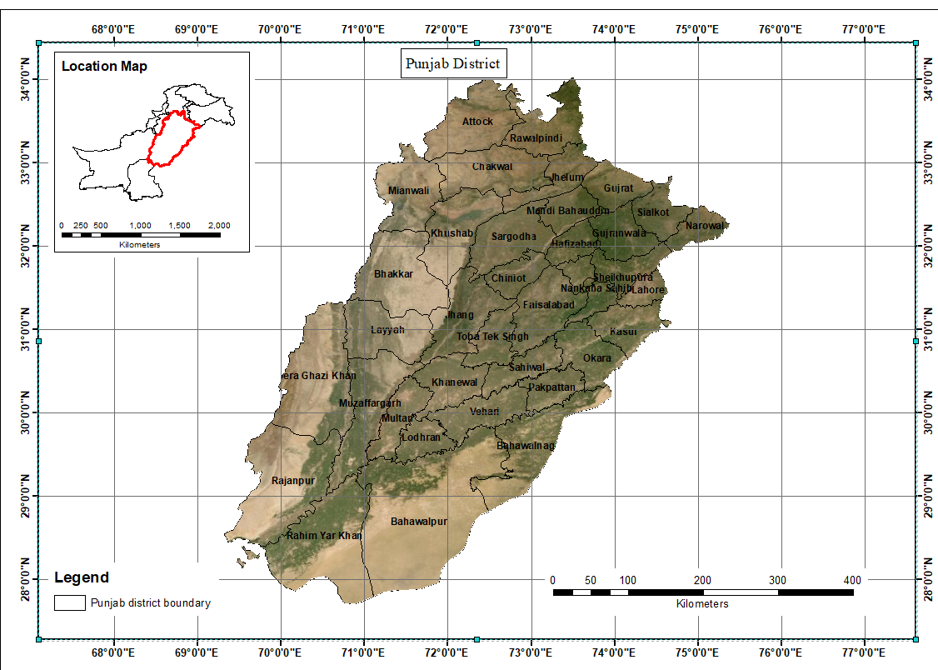

**Figure 1: The study area**

### 3.1.2 Data Parameters and collection:

1. Land Surface Temperature (LST)
2. Population
3. Precipitation
4. 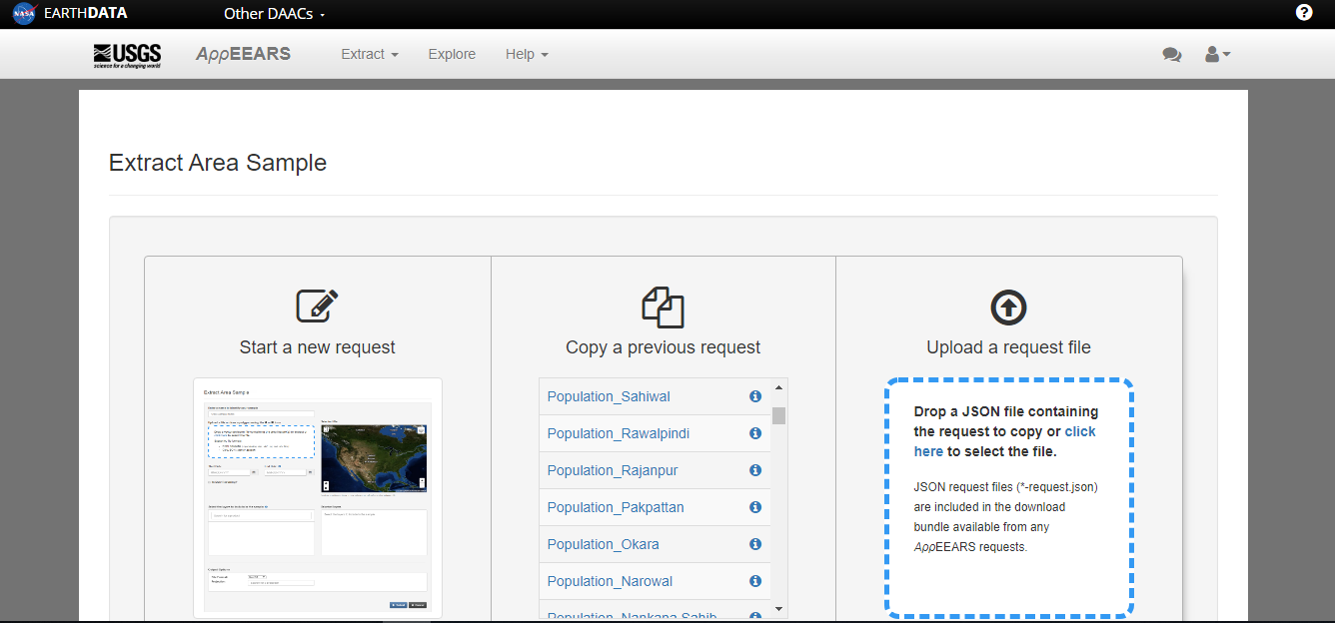Air Quality

**Figure 2: NASA appears request page**

The data for the first two parameters was collected through NASA appEEARS. NASA appEEARS [6] is a web based application for exploring and extracting various satellite data products along with their graphical representations.

Collection of data can be done through using anyone of the two methods provided, first is the “Point sample request” which is used for point data and the second is the “Area sample request” which is obviously used for requesting area sample. For Land Surface Temperature (LST) and Population density “Area sample request” was used. In this method after starting a new request you have to name the sample, select the area whose data is to be collected either by drawing bounding box in the map or by uploading the shapefile (heavy data can affect the download speed and can be sometimes restricted by the website), selection of appropriate satellite data product, setting up a temporal range (for Population) or seasonal range (for LST), selection of data format and coordinate system and the submission of said request. The data request takes some time (depending upon how big data is) and then it’s available in the explore panel where the visualization and downloading options are available.

The data products used for Land Surface Temperature (LST) were of the satellite MODIS (Moderate Resolution Imaging Spectroradiometer) Aqua (EOS PM) and Terra (EOS AM), a 16 days composite data for both day and night respectively. Since the data is to be represented/visualized on the geospatial web portal in time based thematic maps hence the time range for the data was from 2010 to 2019.For LST time range was seasonal (summer and winter with recurring range of 2010 to 2019), summer data consists of month June while the winter data consists of the month of December. The original units of the LST data was in kelvin which were converted into Celsius. Gridded Population of the World (GPW) product from NASA appEEARS was used to collect data for the population density the units of which were number of people persons per km2. The available data products are yearly averaged of year 2010, 2015 and 2020.The values of year 2020 is forcasted data based on the trends of 2010, 2015 and censius data.

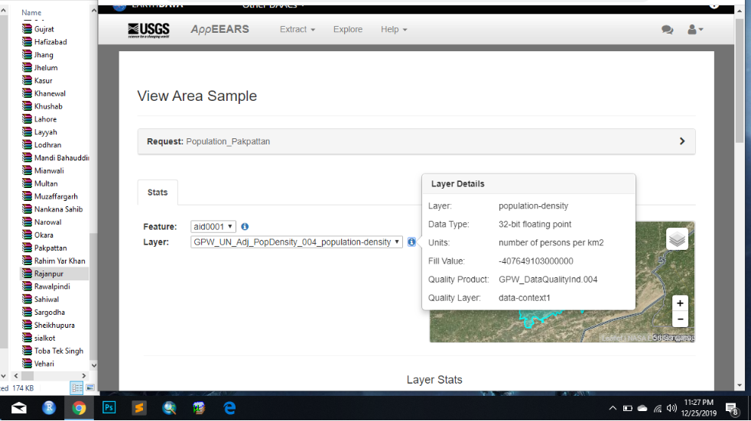

**Figure 3: Viewing Area Sample**

The application appEEARS provides a downloadable CSV file, so for both parameters (LST and Population) all the collected data is in form of CSV. After successful collection of data it was refined and additional information such as max and min values were removed, mean values were calculated and used instead. The refined data is then used for creating choropleth maps which is a type of thematic maps.

### 3.1.3 Creation of Thematic Map in ArcMap:

Before creating choropleth maps the shapefile must contain the appropriate data in this case it is the CSV data (obtained from appEEARS), this is done by the method called inner join in Arc Map. Creation of Choloropeth (a type of thematic map) maps in Arc Map requires classification to be performed in. The classes were created on the basis of “natural break” which resulted in classes in float point values, which were refined and rounded off. The resulting Choropleth map is as follows

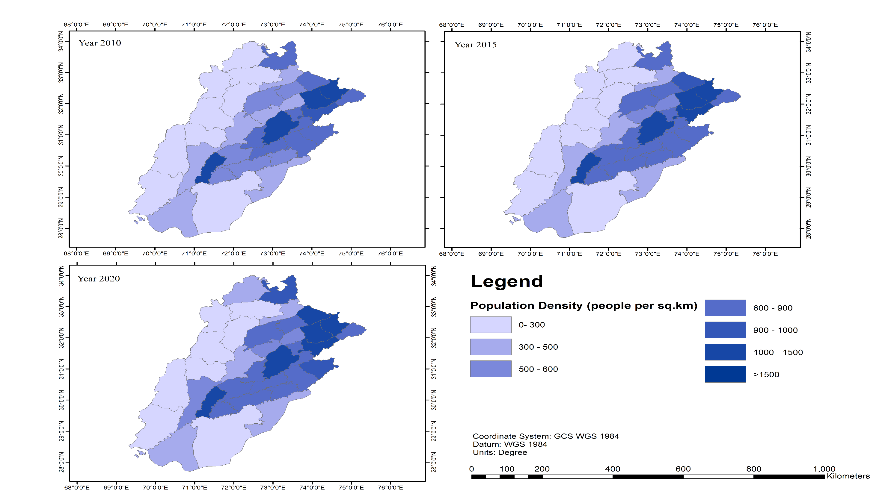

**Figure 4: Punjab Thematic maps**

## 3.2 Geospatial portal development

### 3.2.1 Creation of a Prototype Webpage/Web-GIS browser application:

There are a lot of methods, libraries (JavaScript), software and mapping services to create a Web-GIS browser application such as Map server, OpenLayer, ArcMap Online and Leaflet. In this Project the following things were utilized to create a Geospatial web portal

|  |  |
| --- | --- |
| Html And CSS | In order to create and style the webpage front |
| Bootstrap | To make a dynamic and responsive web-page |
| Leaflet | To enable mapping on the webpage |
| JavaScript | To introduce specific functionalities in the webpage and map such as “onclick” functionality. |
| GeoJson files | Used in creating thematic map for Population Density of Punjab |
| GeoServer | A Server side mapping application which is going to be used for the creation of the remaining Thematic maps due to its simplicity. |

The Prototype Created was initially (before the incorporation of data) as follows

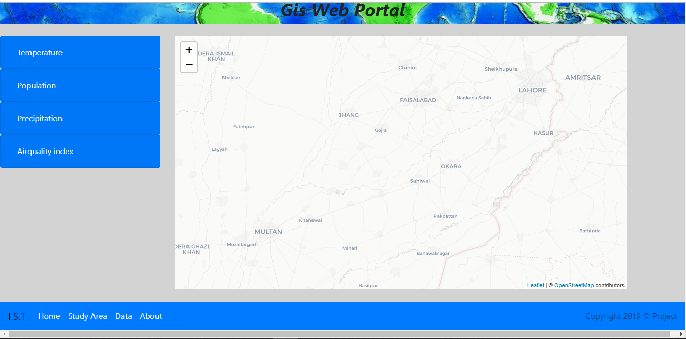

**Figure 5: Prototype webpage**

### 3.2.2 Incorporation of Data into the webpage in order to create thematic map:

For the creation of the Choropleth map of population density of Punjab the Shapefile joined with the downloaded CSV was converted into a GeoJson file which was linked to HTML through the code



A variable “**punjabp**” was assigned to the GeoJson file, through which it was operated upon by JavaScript. Since the data regarding the population was of the year 2010, 2015 and 2020 so the GeoJson file had to be called three times for three separate layers which were combined into a feature group. Through Leaflet layer controls this feature group was displayed on the map.

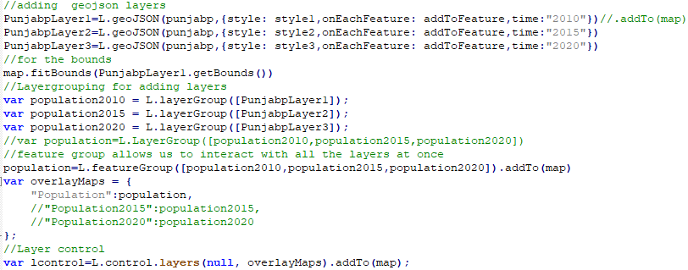

The following functions were used to bring about the colors corresponding to the population density values.

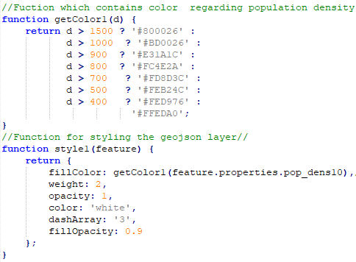

The Choropleth map was styled depending upon the variation of the variable of interest “population density” through styling functions. The Webpage prototype along with the Choropleth map and various plugins is as follows.

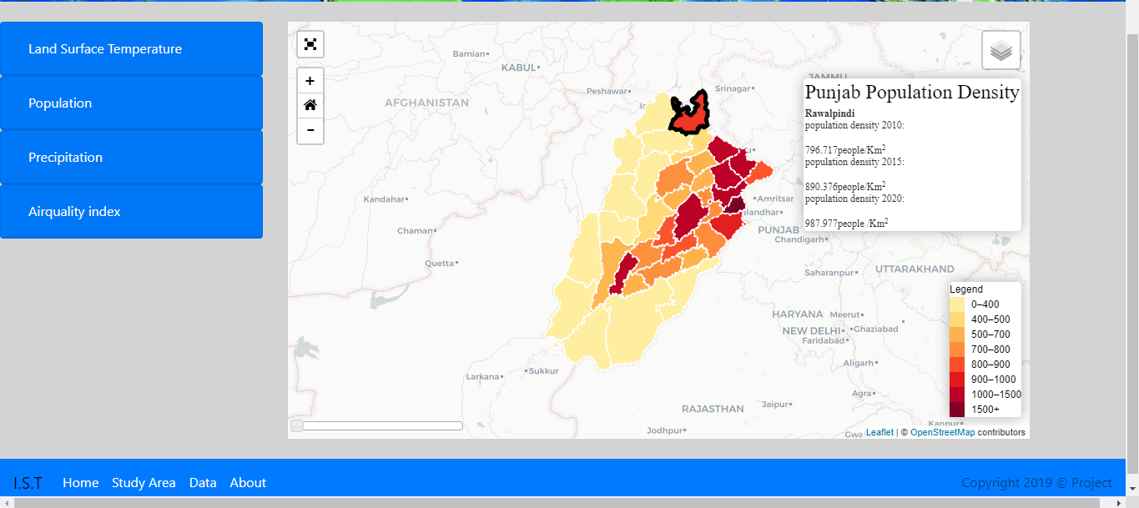

**Figure 5.1: Prototype webpage**

### 3.2.3 Plugins used in the Geospatial web-portal:

|  |  |
| --- | --- |
| Fullscreen plugin | A leaflet plugin utilized to display the map on the entire screen of the device being used to view the map |
| Zoomhome plugin | A leaflet plugin used to zoom to a specific location when clicked |
| Time slider plugin | A leaflet plugin to show various maps overtime |

# **References**

[1][1] A. Noor Anna, Rudiyanto, and V. Nahdhiyatul Fikriyah, “Environmental pollution monitoring using a Web-based GIS in Surakarta,” *IOP Conf. Ser. Earth Environ. Sci.*, vol. 314, no. 1, 2019, doi: 10.1088/1755-1315/314/1/012066.

[2] K. Observatory, C. Istanbul, T. Land, F. Command, and C. E. Faculty, “Developing a Web-Based Gis Application for Earthquake Information,” *Civ. Eng.*, pp. 1–4, 2002.

[3] L. Van Trung and D. M. Tam, “Web GIS Solution for Monitoring the Forest-Cover in the Mekong Delta, Vietnam,” *J. Geogr. Inf. Syst.*, vol. 10, no. 05, pp. 491–502, 2018, doi: 10.4236/jgis.2018.105026.

[4] I. Machdar, T. Zulfikar, R. S. Oktari, H. Fahlevi, and W. Irawati, “Assessment of post-tsunami disaster recovery of Banda Aceh city of Indonesia as window of opportunities for sustainable development Assessment of post-tsunami disaster recovery of Banda Aceh city of Indonesia as window of opportunities for sustainable dev,” pp. 0–11, 2004, doi: 10.1088/1755-1315/56/1/0120.

[5] <https://www.reuters.com/article/us-pakistan-airpollution-court/pakistan-moves-to-curb-urban-air-pollution-after-high-court-ruling-idUSKBN1I11B5>

[6] <https://lpdaacsvc.cr.usgs.gov/appeears>